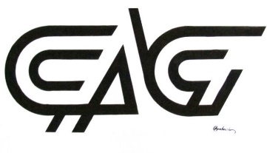

CONTEMPORARY ARTISTS’ GUILD MEMBERSHIP APPLICATION

Name or Names (couples) *:___________________________________________________

Mailing Address*:___________________________________________________________

eMail Address*:_____________________________________________________________

Website:___________________________________________________________________

Social Media (Facebook, Instagram, Twitter, etc.):________________________________
__________________________________________________________________________
__________________________________________________________________________

Member Level*:

Artist Member $50/yr
Student Member $25/yr
Couples Member $75/yr
Preferred Art Medium*:

Self-Identified Skill Level*:

Novice/Beginner
Intermediate
Advanced
Professional

Complete Membership Form and mail it and check made out to the Con to CAG, P.O. Box 3472, Pineville, LA 71361 or email to dfshanks@gmail.com Dues may also be paid online https://www.cagofcenla.com/membership.
If you have any questions, please contact any board member or use the Contact Us Form.
David Shanks – President: dfshanks@gmail.com

